Dashboard Report

- Top Categories by Total Prices
Identity and visually represent the top 10 product categories by total sales.

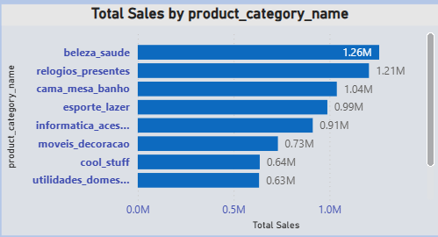

In the Y-axis are product category name and X-axis are Total Sales. We are the using filter to sort the top 10 product category name in the clustered bar chart. In this chart we showing the product category wise total sales means we can do take top one product category this category are show total sales are produce.

example a Beleza saude are one product top category name do total sales 1.26M and
second top sales are relogios presentes are 1.21M.

- Delayed Orders Analysis
Determine the number of delayed orders in each category. An order is considered delayed if the actual delivery date is later than the estimated delivery date.
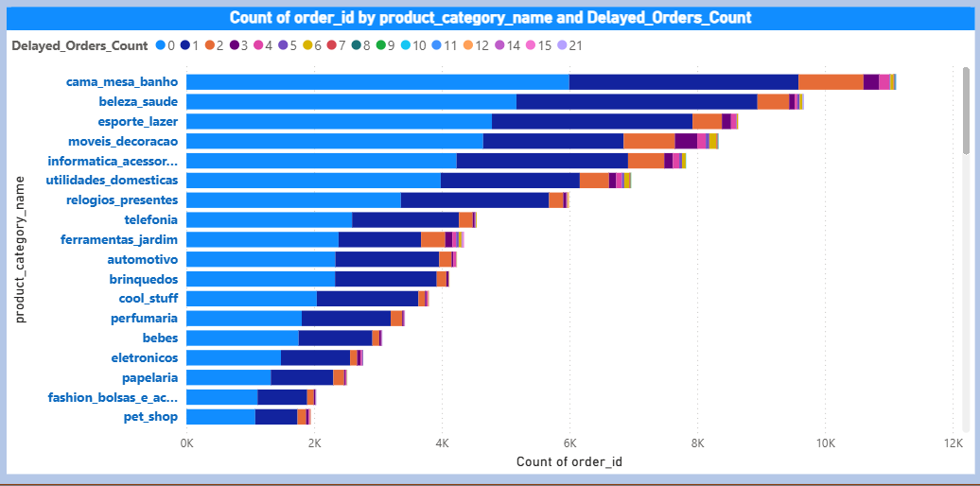

Y-axis Product category name, X-axis order id and legend are Delayed Orders Count.
In Delayed Orders Count we using actual delivery date and compare with estimated delivery date what is we can using formula to create new column.

Delayed_Orders_Count =
VAR Result = CALCULATE(
COUNT(Nexusgoods_order_items_dataset[order_id]),
'Nexusgoods_orders_dataset (1)'[Column7] > 'Nexusgoods_orders_dataset (1)'[Column8]
)
RETURN
COALESCE(Result, 0)

It’s showing number of delayed product per orders the customers. Stacked bar chart using shoe the data and light blue color are Ontime product delivery to customers.

We take any one product name it’s informatica acessorios count 4229 unique order id to on time and this same product 1 order Delayed, 2687 order id unique orders.

- Monthly Comparion of Delayed and On-Time Orders:
Create a dynamic visual that compares the number of delayed orders to the number
of orders received earlier for each month Utilize the drill through cross-report feature to provide a detailed analysis of late and on time deliveries.

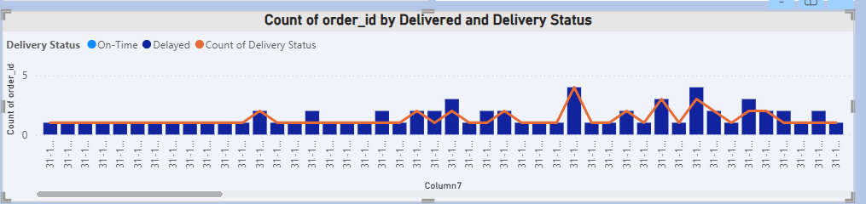

Y-axis column7 (actual delivery date), column Y-axis count the order id, Line Y-axis count of delivery status and column legend delivery status.

In the delivery status again we can compare the date actual delivery date to estimated delivery date
Delivery Status = IF('Nexusgoods_orders_dataset (1)'[Column7] > 'Nexusgoods_orders_dataset (1)'[Column8],"Delayed","On-Time")
Example:-
19-06-2018 12:05 to 18-07-2018 00:00 = Delayed
16-06-2018 15:20 to 18-07-2018 00:00 = On-Time

Actual delivery date 31-12-2017 15:19
Delivery status delayed
Number of order id and delivery status are order delayed 1 time
Means total 1 order their in this 1 order delayed are count 1 time

Actual delivery date 31-10-2017 23:07
Delivery status delayed
Number of Order id 2 and delivery status 1
Total 2 orders out of 2 order 1 order are delayed count.

- Payment Method Analysis
Analyze the most frequently used payment methods by customers using a visually appealing representation, such as a pie chart or other suitable visuals.
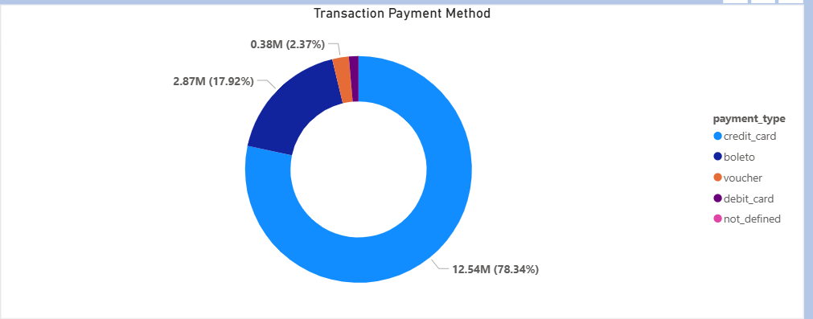

Legend payment type and values payment value using Donet chart.

Total 5 transaction method to using payment options. We take top one most used payment option which is credit card option around 78% used to payments amounts 12.54M and most less payment are using which is cash its mentions not defined.

- Product Rating Analysis
Determine the top 10 highest products and the bottom 10 lowest-rated products using a bar or column chart.

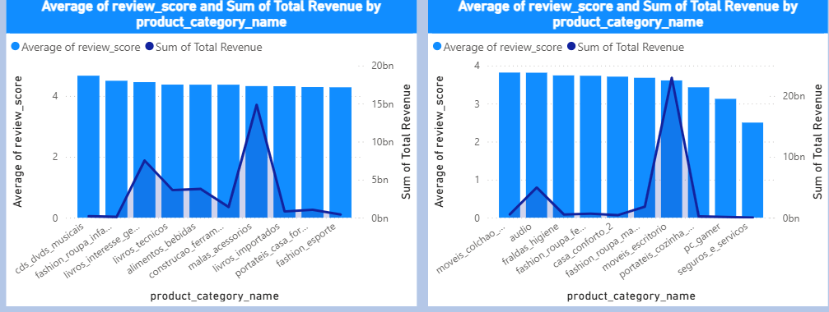

X-axis Product category name, column y-axis average of review score and line y-axis total revenue. First chart do a filter top 10 product category name with score and Second chart filter bottom top 10 product category with score.
In first chart Product category name Malas accessories average score is 4.32 but total revenue is 14842.0749204 Trillions this product max revenue generated, compare to second higher score fashsion roupa infanto juvenil is average score is 4.50 but total revenue is 108.733149 Trillions.
Fashsion roupa infanto juvenil are top less peoduct sell compare to malas accessories.

Same second chart bottom less 4 moveis escritorio average score is 3.61 but total revenue is 22983.4694967 Trillions compare to bottom top 1 product category name moveis colchao e estofado average score is 3.82 and total revenue is 516.48246 Trillions.

- State-wise Sales Analysis
Identify and visually represent states with high & low sales, providing a clear understanding of regional sales performance.

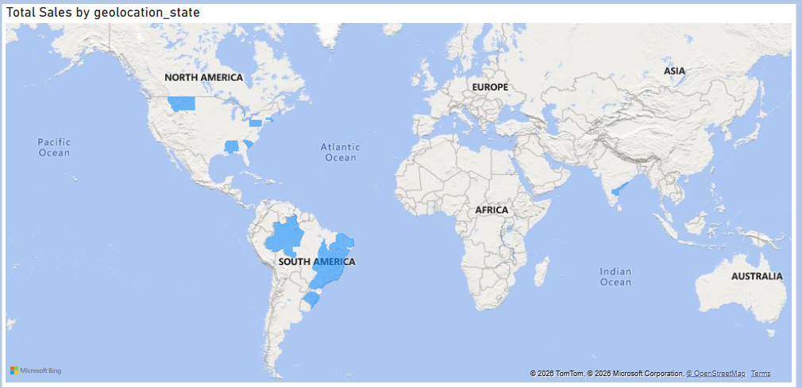

Location is geolocation state and Tooltips is Total Sales.
He show state wise Total Sales particular country states that sold a over products in the good suppliers.

We can see America and south America continent countries, We choose one country like America take one state south Carolina total sales is 632426.07 and Pennsylvania its total sales is 1238. Compare to those two south Carolina is highest states to sales the product and Pennsylvania is lowest states to sales the products.
Any issue are taking here location like South Carolina are many industry available to compare to Pennsylvania and Pennsylvania have mountains and people dependents on
Agriculture supports. Its produce over own products no need to be purchase the external products.

- Seasonal Sales Patterns
Investigate and visualize any seasonal patterns (Quarterly) or tends in sales data over the course of the year.

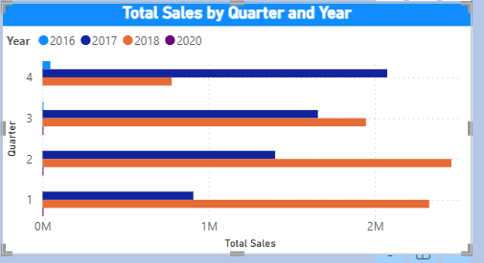

Y-axis is quarter, X-axis is Total Sales and Legend is Year.

In this chart present Quarter, Year with Total Sales.
First show quarter 4 are present year wise total sales
Example We take Quarter 4 section, 2016 2017 2018 total sales present 2016 is 47137.59, 2017 is 2072991.03 and 2018 is 777020.03, then here 2017 is doing higher sales and 2016 is lower sales.

- Revenue Analysis
Determine the total revenue generated by Shop Nest Store & analysis how it changes over time (Yearly). Represent this information through suitable visuals to highlight tends and patterns.

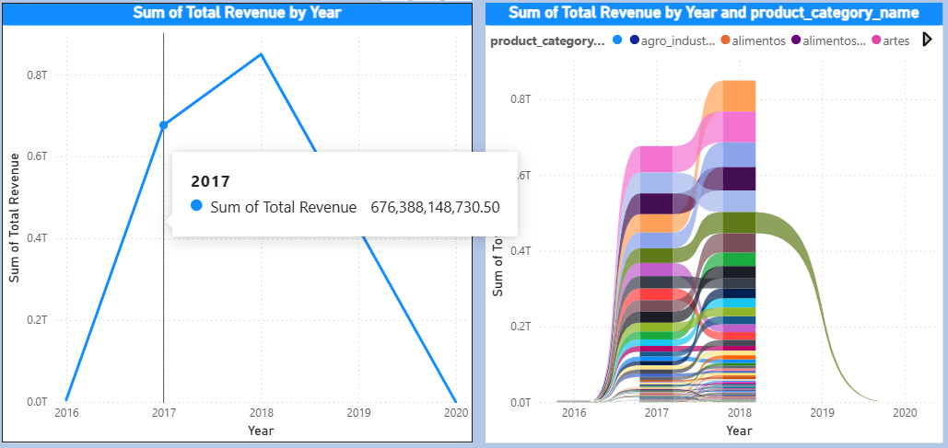

First is Line chart X-axis is Year, Y-axis is Total Revenue and Ribbon chart x-axis is Year, y-axis is total revenue legend is product category name.

In Line chart are shows year with total revenue, in 2018 is highest revenue generated year 849627239330.70 and lowest revenue generated year is 2016 around 5028908169.

In second chart Ribbon chart its showing year wise product revenue increase and decrease ratio.
Example Year 2018 product category is cama mesa banho total revenue are 81400354119.29

Year 2017 product category is cama mesa banho total revenue 69562032456.59

In 2018 cama mesa banho Increase 11,838,321,662.7 compare to last year 2017

Year 2016 product category is cama mesa banho total revenue 108733149.60

In 2017 cama mesa banho increase 69453299306.99 compare to 2016.

